ISSUE 333: Model for Plans

General discussion regarding component parts of CRMsoc:
The sig following its decision to incorporate the models for Activity Plans in the CRMsoc, reviewed Thanasis Velios’s proposed changes on previous MD’s HW and decided to introduce in the CRMsoc the following classes and properties :

socExx Activity Plan
PROPOSAL: socExx Activity Plan be construed as a reactive event specification
DECISION: E29 Design or Procedure isA socExx Activity Plan.

socP1 planned for [D:socExx Activity Plan, R: E70 Thing],
The initial setting of range was to E1 CRM Entity, but MD thought that binding an activity plan to an abstract E1 CRM Entity is far too underspecified to be of any use.
GB explained that this was intentional; in fact, the property was modelled as P67 refers to [R: E1 CRM Entity]// P67.1 has type [R: E55 Type], with the goal of selecting the appropriate type of event.
MD insisted that the property be made more specific, as it does not only associate categorical information with the plan (like the type of event) but information related to particulars as well (participants to the event for instance). Therefore, plans are to be construed as EVENT SPECIFICATIONS (see below “New class socExx Event Specification”)–their participants to be further specified.
The discussion shifted to the fact that an activity plan may never be (selected to be) executed –alternative plans are often concocted –and it’s not always possible to link a plan to the event it specifies. CEO explained that this is in fact a pseudo-problem and the workaround is to assume that activity plans are in a one to one relation with possible (not actual) events. The plan selected to be executed is the plan for the event specified.
Finally the identifier for the property planned for is set to socP1 in the preliminary version of CRMsoc.

socP2 requires type of event [D: socExx Activity Plan, R: socExx Event Specification]
DECISION: The sig reviewed the property definition and decided that its range change to socExx Event Specification (new class to be introduced in CRMsoc). –see below. The initial setting of the range was to E55 Type.
The activity plan must be reactive –i.e. it is to be activated under such and such conditions –the latter are described by the event specification. They are best captured by invoking the type of the event and the type of the participants. These types can be instantiated by particulars, which help further specify the event. Legislative texts should come in handy in this respect.
The identifier for the property requires type of event is set to socP2 in the preliminary version of CRMsoc.

socP3 has assessment [D: socExx Activity Plan, R: E31 Document]
DECISION: the sig reviewed the definition of the property and accepted it as is.
The identifier for the property has assessment is set to socP3 in the preliminary version of CRMsoc.
The definition and scope note are found below:

socP3 has assessment
Domain: socE Activity Plan
Range: E31 Document

Scope note: This property associates an instance of socE1 Activity Plan with an instance of E31 Document which holds the assessment of the activity plan after it has been executed. This property allows reasoning on the quality or effectiveness of the activity plan. It is a shortcut which can be expanded as: socE1 Activity Plan → P140i was attributed by → E13 Attribute Assignment → P141 assigned → E31 Document.

socP4 realized (was realized by) [D: E7 Activity, socExx Activity Plan]
DECISION: the sig reviewed the definition of the property and accepted it as is.
The identifier for the property realised (was realised by) is set to socP4 in the preliminary version of CRMsoc.
The definition and scope note are found below:

socP4 realised (was realised by)
Domain: E7 Activity
Range: socE Activity Plan

Scope note: This property associates an instance of E7 Activity with the instance of E100 Activity Plan of which it is regarded as being a valid execution by the actors holding the ‘intention to apply’. To be valid the E61 Time Primitive associated with the instance of E7 Activity must fall within the E61 Time Primitive foreseen in the E101 Intention to Apply.

Examples: The delivery of a fine to a citizen in the initial enforcement period of Law 3730/2008 against smoking in public/work places (E7) realized provisions of Law 3730/2008 of the Greek Government against smoking in work places (E100).
The conservation of MS Greek 418 (E7 Activity) realised the proposals for its conservation (Activity Plan).

New class socExx Event Specification (of future event)
HW: MD & TV to model event specification (properties linking it to other classes, isA relations with other classes) and come up with a definition of its scope note.
PROPOSAL: MD proposed that the event specification should have properties linking it
(a) to the thing to be acted upon (patient) and
(b) the actor who is to carry it out the activity plan (which isA event specification) –e.g. “a plan to dissolve a company, conceived by x”.

Issue 385: Social Relationships
The sig reviewed MD’s HW class definition of Formal Social Binding.

socExx Bond (former “Formal Social Binding”)
The sig reviewed the definition of socExx Bond (MD’s HW), edited and accepted it. New class definition can be found below.
DECISION: Aside minor editorial changes, the sig resolved to delete property socPxx to [D: socExx Bond, R: E31 Document].
The sig then revisited the properties linking socExx Bond to Actors (their subproperties too) and did some editing.
DECISION: proposed property socP6 [D: socE1 Bond, R: E77 Persistent Item]: its range is to be changed to E70 Thing –in accordance with the scope note definition.
NOTE: The indexes on the classes and properties listed here are preliminary and refer to the schema below:
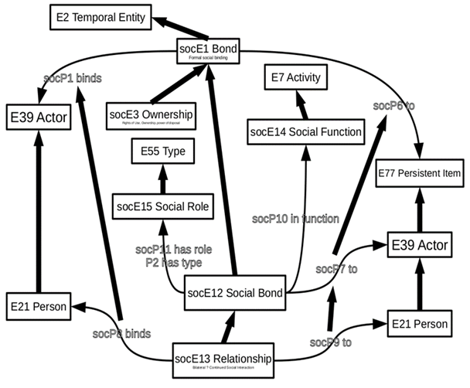
HW: GB, MD to do some literature review regarding speech acts, to best capture bonds as temporal entities.

Bond
Subclass of: E2 Temporal Entity
Superclass of: socE Ownership
socE Social Bond
Scope note:
This class comprises phenomena of formally defined and socially respected bindings between different instances of E39 Actors or between multiple actors and instances of E70 Thing. Instances of SOxxx Formal Social BindingBond come into being and end with an explicit act of declaration or indirectly through other publicly acknowledged events, such as via heritage at birth or death. Depending on their type, they are associated with characteristic rights and obligations, which are subject to the formal legal system of the respecting society, regardless whether this is based on written laws or oral tradition.
Formal Social Bindings Bonds are not observable as such, even though the behavior of involved actors may suggest their existence, such as being married. They are exclusively a consequence of the establishing event, which should be kept as social memory in a persistent documented form or as oral tradition, and the continued respect of this kind of binding by a target community. For instance, a community may declare a certain kind of marriage as invalid from some date on, and later redeclare it as valid. Their existence does not depend on the existence of social memory. Documents may be lost or involved actors may not have been aware of the respective establishing events, but later evidence of the establishing events may be found. In these cases, the society may not act according to the respective rights and obligations as long as the fact remains unknown, but is obliged to when the necessary evidence has been provided. Involved actors may have difficulties proving the existence of the binding to authorities when respective documents are lost, but that does not affect their actual existence. However, certain legal systems may require in certain kinds of cases the provision of evidence itself as part of the establishing event.
In some contexts, Formal Social Bindings are also called social institutions. Examples include memberships, employments, ownerships, rights of use, marriage, parenthood and others. In documentation practice, instances of Formal Social Bindings may bye shortcut by simple binary relations, such as “is married to”.
Examples: John owns his house.
Properties: socP binds: E39 Actor
Also the sig decided to close this issue. Further discussions on CRMsoc will resume in a separate, new CRMsoc issue.

