Wednesday 23/5/2018

ISSUE 360 LRM
The sig reviewed the Pat’s and Trond HW about LRMoo.

F1 Work
We started the discussion about splitting R10 for creating an equivalent to LRM-R18 work has part. The discussion is transferred to the transitivity of R3 and R10 and how they would be consistent. The R3 of an F1 will not necessarily realize the parent of an F1. This motivates the need for a subrelationn of R10 which is not transitive and called ‘complementary synchronous’.
Trond drew the following figure (360a) on the board, then Martin argued about this (360b)
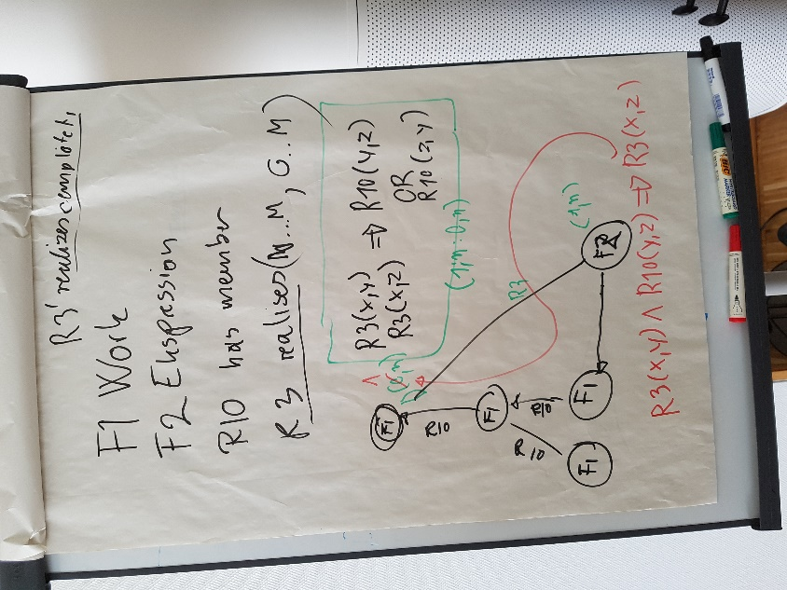  360 a | 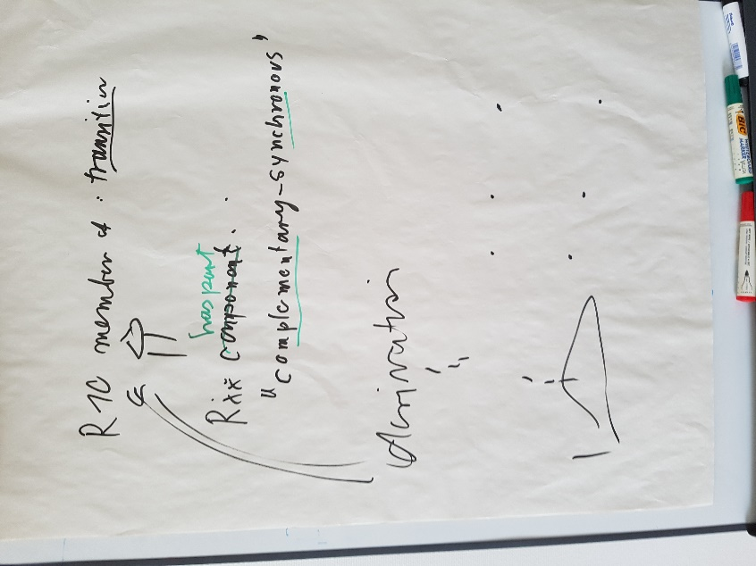  360 b

The sig made minor changes to the scope note of F1 (see appendix E). The propositional content accepted but editing is needed for following the harmonization rules proposed for the scope note. Martin repeated that we should describe substance, identity, existence, utility and purpose.

R10 has member (is member of)
We discussed about Trond’s comment: “We need LRMoo to have a property that is equivalent with LRM-R18. I do not really mind having R10 has member to express both parallel versions and subparts, but if so we will need to distinguish between parallel versions and parts using subproperties of R10”
The sig accepted Martin’s comment “At some point exist together and are intended to exist together simultaneously at some point in time” and decided to add a new property Rxx has part which should be superproperty of R10 and we should make clear the role of this property as generalization over more specific forms of membership.
Thus the sig assigned to Pat, Trond to re write the scope note (see Appendix E) and to Martin to write the scope note of the new property: Rxx has part

R3 is realised in (realises)
The sig discussed about Maja’s and Trond comments (APPENDIX E). The sig distinguished three different work realizations:
- Two different properties, comprehensive realizes and another property 'partially or comprehensively realizes'
- Only comprehensive realization, which requires instantiation of a specific work for that purpose
- Not making the distinction at all between comprehensive and partial realization. Rather express comprehensive realization by explicit description of derivative chains between expressions.
The sig left open which of them we need.

R5 has component (is component of)
The sig reviewed the scope note and accepted it except the text in purple highlited which is still under consideration (see APPENDIX E). The text in purple highlight is a reminder to have an indication on how to express components from other authorship. Typicall example, poetry later put to music. Cavafy-Cohen. (the criterion is authorship coming from another distinct work, not just pre-existing.)
The sig proposed to re-examine the conditions for incorporating foreign expressions as parts.

F2 Expression
The sig reviewed the proposal about F2. The revised scope note is in the appendix E. Decision is to add original examples from previous F22 of FRBRoo 3, to check if F2 Expression is a superclass of F34 KOS and if R41 is needed.

F3 Manifestation
The sig reviewed the proposal about F3 and accepted that when F3 becomes an F2, it means that in principle the F3 could 'incorporate' itself. This would have to be forbidden on the property level.
Specific incorporates property from manifestation to expression. The typical case is not rendered signs (manifestations) but rather expressions (non rendered signs).
HW is assigned to Martin to add a reference to the fact that an F3 can also be an E99 Product Type.
There also needs to be a text to explain how LRM differs from FRBRoo with regards to manifestation product type and manifestation singleton.

R4 embodies (is embodied in)
The sig reviewed the scope note (see Apendix E) and discussed if this property really need to exist or could it be dropped? On the one hand, it could be dropped and this would simplify the model. On the other hand, this exists in LRM proper. It helps to distinguish between incorporation of rendered and or unrendered signs. The scope note should be expanded to indicate the symbolic level of incorporation and we should take into account that if the quantification is 1 to n, then we confirm that the F3 must incorporate at least one expression
The sig assigned this HW to Martin.

R7 is materialization of (is materialized in) [=LRM-R4]
The sig reviewed and revised the scope note of R7 (Appendix E).

F30 Manifestation Creation [=LRM-R7 manifestation creation]
The sig reviewed and revised the scope not of F30 (see APPENDIX E). A comment was that this ‘public’ can be in some cases the person who created the manifestation (e.g. manuscript made someone, they did not intend to communicate with the public.)

Thursday 24/5/2018

ISSUE 360 LRM
Then we continued with the reviewing the current version FRBR-LRM.

F5 Item
The sig accepted Pat’s comment that we do not need specific properties between F5 Item and Fn Storage Unit since an instance of F5 Item can either P46 be composed of an instance of Fn Storage Unit, or P46i form part of Fn Storage Unit (or be equal to it). Besides the CIDOC CRM property P46 is composed of (forms part of) is sufficient (unless we need a specific property for the equivalence relationship between an item and a storage unit). As a consequence they changed the scope note of F5 Item (see appendix E).
Also sig decided to enhance the scope note of P128 to point to the fact that carrying a symbolic object is never precisely complete (HW to MD)

F55
It should be deleted

Fn storage unit
Fn storage unit is not accepted, we should add a paragraph to the F5 item scope note about using P46 and E19 to model the storage unit as an object (HW PLB)

F34 KOS
We changed the title of F34 from KOS to Controlled Vocabulary and we made changes to the text. (see appendix E)

F35 Nomen Use Statement
F35 isA E89, we made changes to the subclasses and we delete the poison's example. (see appendix E)

F12 Nomen
F12 we made changes to the subclasses and to the scope note. (see Appendix E)
The sig decided to initiate a discussion for forming a theory of giving identity of information objects. MD asks for participants to this discussion. OE will participate

F33 Reproduction Event
It is decided to be restricted to item based reproductions only. The sig revised the scope note. (See appendix E)

F54 Utilised Information Carrier Change name?
While was the proposal to deprecate this class, the sig decided to keep it and revised the scope note (see Appenix E). It remains pending the name.

R30 produced (was produced by)
We deleted it

R31 is reproduction of (has reproduction)
We deleted it

F41, F42, R40, R41, R42
Then we continue with representative expression attributes. The sig reviewed the scope notes of F41, F42, R40, R41, R42 decided the following:
F41: to be deprecated.
F42: Sig made minor changes (see Appendix E). It should be reworked and the properties should be redesign (HW to MD)
R40: It should be re design

APPENDIX E: ISSUE 360 LRMoo

F1 Work
Subclass of: E89 Propositional Object
Superclass of: F14 Individual Work (deprecate)
F15 Complex Work (deprecate)
F16 Container Work
F21 Recording Work
Scope note: This class comprises distinct intellectual ideas conveyed in artistic and intellectual creations, such a poems, stories or musical compositions.
A Work is the outcome of an intellectual process of one or more persons. Inherent to the notion of work is the existence of recognisable realizations of the work in the form of one or more expressions. Works are often regarded as finished and discrete e.g. when declared as such by the creator of the work or based on the elaboration or logical coherence of its content. However, works may be recognized as existing but unfinished e.g. if the creators deliberately or accidentally never explicitly finished a particular Expression but have left behind partial expressions.
In the absence of explicit information about the initial conception, which is rarely available, the first expression created constitutes witness of the beginning of existence of a Work.
A Work can evolve over time, such as through revised editions. A Work may be elaborated by one or more Actors simultaneously, in parallel or over time. Additional expressions of a Work can continue to be created over time.
The boundaries of a Work have nothing to do with the value of the intellectual achievement but only with the dominance of a concept.
The main purpose of this class is to enable bringing together intellectually equivalent Expressions in order to display to a user all available alternatives of the same intellectual or artistic content.

R10 has member (is member of)
Domain: F1 Work
Range: F1 Work
Superproperty of: Rxx has part (-> the complementary synchronous part)
Subproperty of: E89 Propositional Object. P148 has component (is component of): E89 Propositional Object
Quantification: (0,n:0,n)
Scope note: This property associates an instance of F1 Work with another instance of F1 Work that forms part of it. This property is transitive. An instance of F1 Work may neither directly nor indirectly be member of itself. Instances of F1 Work that are not member of another one may not share a common member.
Examples: Dante’s textual work entitled ‘Divina Commedia’ R10 has member Dante’s textual work entitled ‘Inferno’
Giovanni Battista Piranesi’s graphic work entitled ‘Carceri’ (F15) R10 has member Giovanni Battista Piranesi’s graphic work entitled ‘Carcere XVI: the pier with chains’

R3 is realised in (realises) [=LRM-R4]
Domain: F1 Work
Range: F2 Expression
Superproperty of: F20 Performance Work. R12 is realised in (realises): F25 Performance Plan
F21 Recording Work. R13 is realised in (realises): F26 Recording
F1 Work. R40 has representative expression (is representative expression for): F22 Self-Contained Expression
Subproperty of: E70 Thing. P130 shows features of (features are also found on): E70 Thing
Quantification: (0,n:1,n)
Scope note: This property associates an instance of F2 Expression with an instance of F1 Work.
This property expresses the association that exists between an expression and the work that this expression conveys. Our factual knowledge of how a given work is historically realised into expressions is often limited. Therefore, this property makes it possible to express the association between instances of F2 Expression and the work it conveys without identifying the particular instances of Expression that were the source.
Examples: Dante’s work entitled ‘Inferno’ (F1) R3 is realised in the Italian text of Dante’s ‘Inferno’ as found in the authoritative critical edition La Commedia secondo l’antica vulgata a cura di Giorgio Petrocchi, Milano: Mondadori, 1966-67 (= Le Opere di Dante Alighieri, Edizione Nazionale a cura della Società Dantesca Italiana, VII, 1-4)
Mozart’s work entitled ‘Il dissoluto punito ossia il Don Giovanni’ (F1) R3 is realised in the notated music of the Prague version, as found on manuscript Ms 1548 of the National Library of France (F2)
Properties: R3.1 has type: E55 Type

R5 has component (is component of)
Domain: F2 Expression
Range: F2 Expression
Subproperty of: E89 Propositional Object. P148 has component (is component of): E89 Propositional Object
Quantification: (0,n:0,n)
Scope note: This property associates an F2 Expression X with a structural component Y that conveys a part of the overall work realized by X, such as volumes, chapters, paragraphs.
Any part of an expression that conveys complete propositions, such as a single phrase, can be documented using the more general property P148 has component (is component of).
Any part of an expression that does not completely follow meaningful boundaries, such as lines or pages of text or portions visible on images can be documented using the property P106 is composed of (forms part of), and not with R5 has component (is component of). Fragments in particular can be documented with the more specific property R15 has fragment (is fragment of).
The property does not cover the relationship that exists between pre-existing expressions that are re-used in a new, larger expression and that new, larger expression. Such a relationship is modelled by P165 incorporates.
Examples: The Italian text of Dante’s textual work entitled ‘Divina Commedia’ (F2) R5 has component the Italian text of Dante’s textual work entitled ‘Inferno’ (F2)
The musical notation of Mozart’s Singspiel entitled ‘Die Zauberflöte’ (F2) R5 has component the musical notation of Mozart’s aria entitled ‘Der Hölle Rache’, also known as ‘The Queen of the Night’s Aria’ (F2)
The visual content of the map entitled ‘Wales – The Midlands – South West England’, scale 1:400,000, issued by Michelin in 2005 (F2) R5 has component the visual content of the inset entitled ‘Liverpool’, scale 1:200,000, set within the compass of the map titled ‘Wales – The Midlands – South West England’, scale 1:400,000, issued by Michelin in 2005 (F2)

F2 Expression
Subclass of: E73 Information Object
Superclass of:
F34 KOS (just check )
F43 Identifier Rule just check to see along with linked open data rules
F25 Performance Plan
F26 Recording
F3 Manifestation

Scope note: This class comprises the intellectual or artistic realisations of works in the form of identifiable immaterial objects, such as texts, poems, jokes, musical or choreographic notations, movement pattern, sound pattern, images, multimedia objects, or any combination of such forms that have objectively recognisable structures. The substance of F2 Expression is signs.
An Expression is the outcome of the intellectual or creative process of realizing a Work. Subsequent expressions conveying the same work may be created over time.
Expressions do not depend on a specific physical carrier and can exist on one or more carriers simultaneously, including human memory, but expressions cannot persist without a carrier.
The form of F2 Expression is an inherent characteristic of the F2 Expression. Differences in form implies different Expressions (e.g., from text to spoken word, a transcript of a recording). Similarly, differences in language or means of performance imply different Expressions (e.g., translations or arrangements for different instruments). Thus, if a text is revised or modified, the result is considered to be a new F2 Expression. While theoretically any change in signs will result in a new Expression, conventionally the context and use will determine the rules for distinguishing among expressions.
Examples: The Italian text of Dante’s ‘Divina Commedia’ as found in the authoritative critical edition ‘La Commedia secondo l’antica vulgata a cura di Giorgio Petrocchi’, Milano: Mondadori, 1966-67 (= Le Opere di Dante Alighieri, Edizione Nazionale a cura della Società Dantesca Italiana, VII, 1-4) (F2 and E33)
The Italian text of Dante’s ‘Inferno’ as found in the same edition (F22 and E33)
The signs which make up Christian Morgenstern’s ‘Fisches Nachtgesang’ [a poem consisting simply of ‘—’ and ‘˘’ signs, arranged in a determined combination] (F22)
Properties: R4 carriers provided by (comprises carriers of): F3 Manifestation Product Type
R5 has component (is component of): F2 Expression
R15 has fragment (is fragment of): E90 Symbolic Object
R41 has representative manifestation product type (is representative manifestation product type for): F3 Manifestation Product Type (it might be not needed)

F3 Manifestation
Subclass of: F2 Expression
Scope note: This class comprises products rendering one or more Expressions. A Manifestation is defined by both the overall content, its physical form and presentation. The substance of F3 Manifestation is signs and the way signs are presented to be consumed by users.
A F3 Manifestation is the outcome of a publication process where one or more F2 Expression are prepared for public dissemination, but it may also be a unique form created directly on some carrying material without the intent of being formally published.
An instance of F3 Manifestation must incorporate one or more instances of F2 Expression and all additional input by a publisher such as text layout and cover design. Additionally a F3 Manifestation can be identified by the physical features for the medium of distribution if applicable. For example, hardcover and paperback are two distinct publications (i.e. two distinct instances of F3 Manifestation) even though authorial and editorial content are otherwise identical in both publications.
In case of industrial products such as printed books or music CDs, but also digital material, an instance of F3 Manifestation can be regarded as the prototype for all copies of it. In these cases, an instance of F3 Manifestation defines all of the features or traits that instances of F5 Item display in order to be copies of a particular publication.

R4 embodies (is embodied in)
Domain: F3 Manifestation
Range: F2 Expression
Subproperty of: E73 Information Object. P165 incorporates (is incorporated in): E90 Symbolic Object
Quantification: (1,n:0,n)
Scope note: This property associates one or more instances of F2 Expression with an instance of F3 Manifestation which is the rendering of these expressions.
Examples: The publication identified by ISBN ‘2-222-00835-2’ (F3) R4 incorporates the text of Marin Mersenne’s ‘Harmonie universelle’ (F2)
The CD entitled ‘Musique de la Grèce antique = Ancient Greek music = Griechische Musik der Antike’, released in 2000 and identified by UPC/EAN ‘794881601622’ (F3) R4 incorporates A recording of the Atrium Musicæ Ensemble’s performance of a fragment of Euripides’ textual and musical work entitled ‘Orestes’ (F26)

R7 is materialization of (is materialized in) [=LRM-R4]
Domain: F5 Item
Range: F3 Manifestation
Subproperty of: E24 Physical Man-Made Thing. P128 carries (is carried by): E73 Information Object
Quantification: (1,1:0,n)
Scope note: This property associates a manifestation with one of its exemplars or its only exemplar. Instances of F5 Item correspond to the kinds of physical unit(s) specified in the manifestation, regardless of possible later changes.
Even though an item may exhibit defects with respect to the intended manifestation, it is still regarded to carry the manifestation, as long as it is produced or made accessible as a functional item by its creators.
Examples: The item held by the National Library of France and identified by shelf mark ‘Res 8 P 10’ (F5) R7 is materialization of the edition of Amerigo Vespucci’s textual and cartographic work entitled ‘Mundus novus’ issued in Paris ca. 1503-1504 (F3)

F30 Manifestation Creation [=LRM-R7 manifestation creation]
Subclass of: F28 Expression Creation
Scope note: This class comprises the activities of selecting, arranging and elaborating one or more expressions to the level of the actual or intended sensory impression of a respective carrier or other persistent presentation means of it with the purpose of communicating it to some public.

Examples: Establishing in 1972 the layout, features, and prototype for the publication of ‘The complete poems of Stephen Crane, edited with an introduction by Joseph Katz’ (ISBN ‘0-8014-9130-4’), which served for a second print run in 1978
Creating the article by Allen Renear, Christopher Phillippe, Pat Lawton, and David Dubin, entitled ‘An XML document corresponds to which FRBR Group 1 entity?’ as online available at <http://conferences.idealliance.org/extreme/html/2003/Lawton01/EML2003Lawton01.html>
Properties: R23 created a realisation of (was realised through): F19 Publication Work
R24 created (was created through): F3 Manifestation

F5 Item
Subclass of: F54 Utilised Information Carrier
Scope note: This class comprises physical objects (printed books, scores, CDs, DVDs, CD-ROMS, etc.) that were produced by (P186i) an industrial process involving a given instance of Fn Manifestation. As a result, all the instances of F5 Item associated with a given instance of Fn Manifestation are expected to carry the content defined in that instance of Fn Manifestation, although some or even all of them may happen to carry a content that significantly differs from it, due to either an accident in the course of industrial production, or subsequent physical modification or degradation. Storage unit might be different. Use E19 physical object and P46 composed of (forms part of).
Examples: Marin Mersenne’s personal copy of his own ‘Harmonie universelle’ without any manuscript addition and without Charles Racquet’s manuscript score, as a mere witness of the 1st edition of ‘Harmonie universelle’, Paris, 1636 [the same physical object can be regarded at the same time as an instance of F5 Item inasmuch as it is a witness of a publication, and as an instance of F4 Manifestation Singleton inasmuch as it contains manuscript annotations and additions and as it served as the basis for a subsequent production process]
Any other copy of the original edition of Marin Mersenne’s ‘Harmonie universelle’, Paris, 1636
Any copy of the modern reprint publication of Marin Mersenne’s ‘Harmonie universelle’, Paris, 1986, ISBN ‘2-222-00835-2’
Properties: R7 is example of (has example): F3 Manifestation Product Type

F34 Controlled Vocabulary
Subclass of: E32 Authority Document
E29 Design or Procedure
F2 Expression
Scope note: This class comprises documents that establish controlled terminology (nomina) for consistent use. They may also describe relationships between entities and controlled terminology and relationships between entities. Note that any meaningful change in a Controlled vocabulary that affects the validity status of its elements defines a new release (Expression) of the Controlled vocabulary. Note that identifiers created following a rule in a Controlled vocabulary are to be regarded as being taken from this Controlled vocabulary, even though not explicitly spelled out. This definition of Controlled vocabulary reflects current library practice and not the use of the term in general. Knowledge Organisation Systems (KOS) are regarded as special cases of F34 Controlled Vocabulary. Add example(s): Pat.
Examples: LCSH February 20 to March 19 2012
DDC 19 [19th English edition, published only in print by Forest Press in 1979]
Properties: R34 has validity period (is validity period of): E52 Time-Span

F35 Nomen Use Statement
Subclass of: F12 Nomen
Scope note: This class comprises statements relating an instance of E1 CRM Entity with a particular instance of F12 Nomen and its prescribed usage in a given context.
Examples: Add example from DDC or UDC.
‘010 __ |a sh 85082387’…‘450 __ |a Equations, Maxwell’ [MARC 21 encoding of a variant subject access point, from the same source]
‘PTBNP|20891’…‘200 1‎‡a Whitman,‏ ‎‡b Walt,‏ ‎‡f 1819-1892‏’ [UNIMARC encoding of the preferred access point for a personal name, from the authority file of the National Library of Portugal, as found on VIAF, http://www.viaf.org/processed/PTBNP%7C20891, on 28 September 2015]
‘001 FRBNF119547493’…‘100 w.0..barus.$aGončarova$mNatalʹâ Sergeevna$d1881-1962’ [INTERMARC encoding of the preferred access point for a personal name, from the authority file of the National Library of France, http://catalogue.bnf.fr/ark:/12148/cb119547494/ INTERMARC, as of 15 June 2012]
‘001 FRBNF119547493’…‘100 w.0..c.rus.$aГончарова$mНаталья Сергеевна$d1881-1962’ [INTERMARC encoding of a parallel access point from the same source]
‘001 FRBNF119547493’…‘400 $w....b.eng.$aGoncharova$mNatalia$d1881-1962’ [INTERMARC encoding of a variant access point from the same source]
‘<eac-cpf […]> <control> <recordId>beinecke.7h44jbj</recordId> […] </control>’ … ‘<cpfDescription> <identity> <entityType>family</entityType> <nameEntry xml:lang="eng" scriptCode="Latn"><part localType="100a">Boswell family</part> […] </nameEntry> […] </identity> </cpfDescription> […] </eac-cpf>’ [EAC encoding of the preferred access point for a family]
Properties: R32 is warranted by (warrants): F52 Name Use Activity
R35 is specified by (specifies): F34 KOS
(R35.1 has status: E55 Type)
R36 uses script conversion (is script conversion used in): F36 Script Conversion
R37 states as nomen (is stated as nomen in): F12 Nomen
R38 refers to thema (is thema of): E1 CRM Entity
R39 is intended for (is target audience in): E74 Group
R54 has nomen language (is language of nomen in): E56 Language
R55 has nomen form (is nomen form in): E55 Type
R56 has related use (is related use for): F35 Nomen Use Statement
(R56.1 has type: E55 Type)

F12 Nomen
Subclass of: E89 Propositional Object
Superclass of: F35 Nomen Use Statement
Scope note: This class comprises associations between an instance of any class, and signs or arrangements of signs following a specific syntax (sequences of alphanumeric characters, chemical structure symbols, sound symbols, ideograms etc.) that are used or can be used to refer to and identify that instance. The scripts or type sets for the types of symbols used to compose an instance of F12 Nomen have to be explicitly specified. Spelling variants are regarded as different nomina, whereas the use of different fonts (visual representation variants) or different digital encodings does not change the identity.
An arbitrary combination of signs or symbols cannot be regarded as an appellation or designation until it is associated with something in some context. In that sense, the F12 Nomen class can be understood as the reification of a relationship between an instance of E1 CRM Entity and an instance of E41 Appellation. Two instances of F12 Nomen can happen to be associated with two identical instances of E62 String and yet remain distinct, as long as they either refer to distinct instances of E1 CRM Entity, or as long as they are associated with distinct instances of other classes through one or more than one of the other properties of the F12 Nomen class (while referring to the same instance of E1 CRM Entity).
An instance of F12 Nomen associates a combination of signs with an instance of E1 CRM Entity on the basis of a cultural or linguistic convention: by associating a nomen string with anything, the instance of F12 Nomen establishes a meaning that is not inherent in the instance of E62 String that is associated with it. Depending on context of use, nomens associated with identical strings can involve instances of different things in the real world even within the same language (polysemy and homonymy). Conversely, the same thing can be referred to through any number of nomens (synonymy). In the controlled environment of a bibliographic information system, though, synonymy is avoided and the instances of E62 String associated with a given instance of F12 Nomen would generally be disambiguated, so that each nomen string is associated with only one instance of E1 CRM Entity within the specific scheme.
The identity of an instance of F12 Nomen is determined by the combination of the thing it refers to, the choice and order of the symbols used within the instance of E62 String that represents it, and the specific instances of the various classes with which it is associated through all other properties of the F12 Nomen class. Variation in the symbols used (such as transliteration into another script) or variation in their ordering usually results in a distinct instance of F12 Nomen, but variation in the visual representation of the symbols present in the instance of E62 String that represents the instance of F12 Nomen (such as different fonts that may be used to present alpha-numeric or character strings) does not result in a different nomen string.
Instances of F12 Nomen are assigned and associated with instances of E1 CRM Entity either formally (such as by bibliographic agencies) or informally through common usage. When they are assigned formally, the construction of the instances of E62 String that represent them may follow predetermined rules.
The act of naming something may involve the combination of various symbolic objects, which may be instances of F12 Nomen in their own right, and therefore refer to distinct instances of E1 CRM Entity, or just be used as qualifiers. A frequent example is provided by the tradition consisting of naming persons by juxtaposing a given name (such as 'John'), and a last name (such as 'Smith') which is shared by all members of the same family. The given name alone can be sufficient to refer unambiguously to a given individual in a given context, but not in a wider context, in which the combination of given name plus last name proves necessary. Similarly, the combination of given name plus last name may be ambiguous in an even wider context, in which case the need for further qualifiers (such as a nickname, or, in the context of bibliographic control, dates and statement of occupation) can be felt. An instance of F12 Nomen can therefore be decomposed into further reifications that refer to distinct things through distinct strings, and/or instances of E90 Symbolic Object that serve merely as qualifiers and do not refer to anything in particular.

F33 Reproduction Event
Subclass of: E12 Production, F30 Publication Event
Scope note: This class comprises activities that consist in producing items of a new instance of Fn Manifestation that preserve both the content and layout found on items of a pre-existing instance of Fn Manifestation. The individual instance or instances of F5 Item that was or were used as a source for this process may be precisely identified or not. Such activities result in products known as facsimiles, reproductions, reprints, reissues, or new releases.
Examples: The 2014 publication of Daniel Wilson's 'Caliban: the missing link' by Cambridge University Press (a facsimile edition of the 1873 publication by Macmillan)
The 2015 publication of Harry Partch's 'Two studies on ancient Greek scales' by Schott (which reproduces Harry Partch's holograph manuscript)
Properties:
R30 produced (was produced by): Fn Manifestation
Rn reproduced object (was object reproduced by): E84 Information Carrier
Rn reproduced publication: Fn Manifestation

F54 Utilised Information Carrier Change name?
Subclass of: Physical object
Superclass of: F53 Material Copy
F5 Item
Scope note: This class comprises physical objects that carry one or more instances of Fn Manifestation.
Examples: The physical features created on my PC’s hard drive when I clicked on the link <http://cidoc.ics.forth.gr/docs/cidoc_crm_version_4.0.pdf>, and thus downloaded a reproduction of the electronic file titled ‘Definition of the CIDOC Conceptual Reference Model… version 4.0’ that is stored on the ICS FORTH’s servers in Heraklion, Crete (F53)
Any copy of the modern reprint publication of Marin Mersenne’s ‘Harmonie universelle’, Paris, 1986, ISBN ‘2-222-00835-2’ (F5)
Properties: R6 carries (is carried by): Fn Manifestation

F42 Representative Expression Assignment
Subclass of: E13 Attribute Assignment
Scope note: To be reworked. This class comprises activities through which an Agency declares (implicitly or explicitly) that a given instance of F2 Expression is representative for a given F15 Complex Work, i.e., that some attributes of that instance of F2 Expression (most prominently, information about the title) can be inferred to also apply to that instance of F15 Complex Work, no matter in which particular expression it is realised.
The reasoning behind this is that the Work title is known through the title of an Expression that is deemed representative of the Work, and the title of the representative Expression is known through the title of a Manifestation that is deemed representative of the Expression that is representative of the Work.
For instance, by using the qualified controlled access point ‘Poe, Edgar Allan, 1809-1849. Murders in the rue Morgue (French)’ for the French rendition of Poe’s ‘Murders in the rue Morgue’ by Baudelaire, an Agency implicitly states that the French text does not constitute a representative F2 Expression for Poe’s F1 Work, however the original English text does constitute a representative F2 Expression for Poe’s F1 Work.
Examples: Selecting the text embodied in the 1775 edition of Richard Brinsley Sheridan’s textual work entitled ‘St. Patrick’s Day’ as the representative expression for Richard Brinsley Sheridan’s textual work entitled ‘St. Patrick’s Day’ and citing that publication as the source for the authority record created by the Library of Congress for that work
Selecting the musical notation embodied in the 2007 edition of John Tavener’s musical work entitled ‘The Eternal Sun’ as the representative expression for John Tavener’s musical work entitled ‘The Eternal Sun’ and citing that publication as the source for the authority record created by the National Library of France for that work
Selecting the publication expression of the 1983 edition of Stanley Karnow’s textual work entitled ‘Vietnam, the war nobody won’ as the representative expression for the series entitled ‘Headline series’ and citing that publication as the source for the authority record created by the Library of Congress for that series
Selecting the publication expression of the issue dated October 2002 of the periodical entitled ‘The New Courier’ as the representative expression of the periodical entitled ‘The New Courier’ and citing that publication as the source for the bibliographic record created by the National Library of France for that periodical
Selecting the content of the manuscript identified by shelfmark ‘MS-8282’ within the collections of the National Library of France, Department for Music, as the representative expression of Stanislas Champein’s musical work entitled ‘Vichnou’ and citing that manuscript as the source for the authority record created by the National Library of France for that work
Properties: R44 carried out by (performed): F44 Bibliographic Agency
R50 assigned to (was assigned by): F1 Work
R51 assigned (was assigned by): F2 Expression
Rn de-assigned: F2 Expressions
Rn declared aspect: E55 Type

