Issue 337: Excavation Interface
Cologne, January 2018

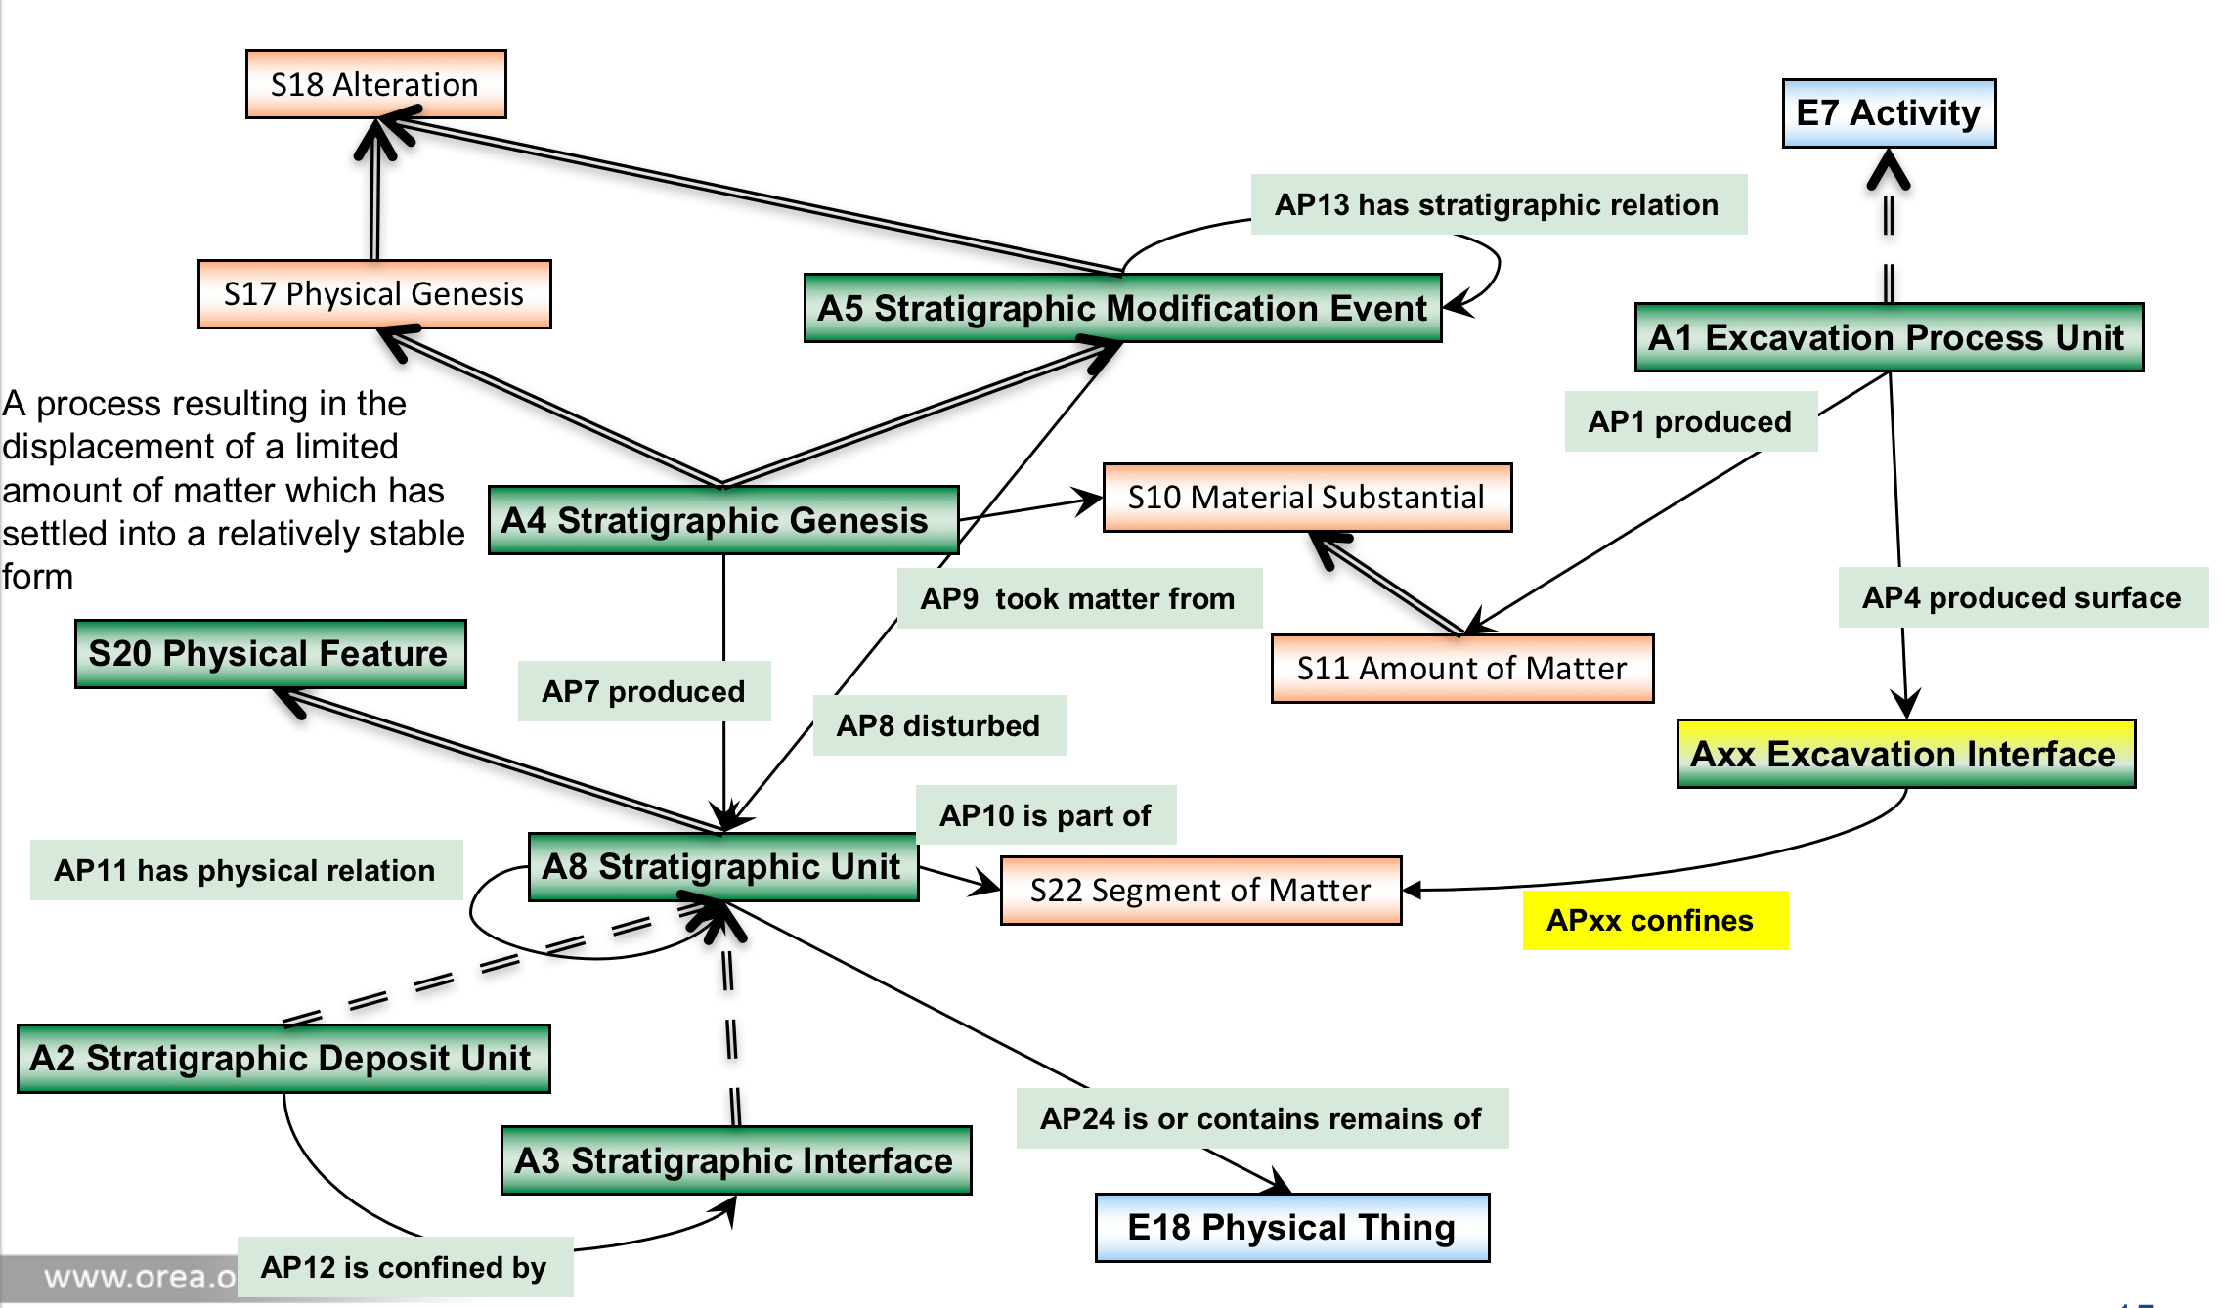

Axx Excavation Interface

Subclass of: S20 Rigid Physical Feature

Scope Note: This class comprises instances of S20 Rigid Physical Feature that constitutes a surface produced through one or several A1 Excavation Process Units. Instances are often documented through drawing and/or measured by technical means such as photography, tachymetry or laser scanning. Using a planar excavation methodology this is typically the surface of a planum or the surface of a profile/section. Using a stratigraphic excavation methodology the Axx Excavation Interface would have the intention to approximate an A3 Stratigraphic Interface. The drawing and measurement of profiles is also common practice when a stratigraphic excavation methodology is used.
.
Examples:
The Excavation Interface Planum 6 of square I22 in Area F-I is documented in the field drawing “Planum 6 F-I i22 “ created in Fall 1982

Properties:
APxx confines (is confined by): S22 Segment of Matter

APxx confines (is confined by)

Domain: Axx Excavation Interface
Range: S22 Segment of Matter

Quantification: one to many (0,n:0,1)

Scope note: This property identifies partly or completely the surface (Axx Excavation Interface) of a S22 Segment of Matter that was excavated during one or several A1 Excavation Process Units. In case of a planar excavation methodology this may be the S22 Segment of Matter contained between two planums as upper and lower boundaries and limited by e.g. four Profiles to the north, east,south and west. The documentation of the excavation interfaces should help to document the structure and composition of the S22 Segment of Matter that they confine. Using a stratigraphic excavation methodology the S22 Segment of Matter is intended to approximate an A2 Stratigraphic Volume Unit.

Examples:
- The Excavation Interface Eastern profile of square I22 in Area F-I is documented in field drawing “Ostprofil F-I i22” confines the excavation square I22 to the east.
[HW to GH: References to the examples are needed]

AP4 produced surface (was surface produced by)

Domain: A1 Excavation Process Unit
Range: Axx Excavation Interface

Quantification: one to many (0,n:0,1)

Scope note: This property identifies the instance of an Axx Excavation Interface that constitutes the new surface produced during one or several A1 Excavation Process Units in the excavated area. Frequently this surface or parts of it are documented through drawing and/or measured by technical means such as photography, tachymetry or laser scanning.
Examples:
The stratigraphic Excavation Process Unit excavating the Stratigraphic Volume Unit (2) produced surface S1.
The stratigraphic Excavation Process Unit excavating the volume (S22 Segment ) between Planum 5 and Planum 6 produced surface Planum 6 .

